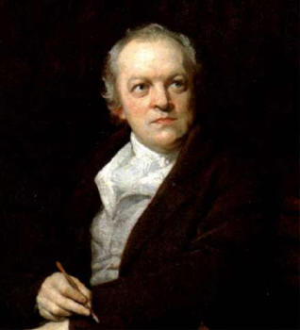 William Blake
The late eighteenth century pioneered new schemes for education and a new literature written explicitly
for children, and the writers of this era turn to children as both a topic of literature and a putative audience. In this way, Blakes works focus on the new rather than the old, on the ﬁgure of the child as an emblem of revolutionary hope. The new child becomes a symbol of a transﬁgured, democratized world. While the literature beholds the world through the perspective of young, untainted eyes, it also presents for the child the values it will need to thrive in the world.

Blake’s poems offer the perfect opportunity to analyze poetry as a multimedia event. Three of his illustrations from our text are included in the text (the title page to Songs of Innocence, the title page to Songs of Experience, and the watercolor illustration of “The Tyger”). Blake’s poetry is intimately connected to his painting and etching. Teaching the poems with the illustrations is important because it re-creates a sense of the original way Blake issued the poems and so helps to create the intended
context for them, but it also emphasizes the symbolic and ironic potential of the poetry. Additionally, reading a series of paired poems from the two collections neatly illustrates the “two contrary states of the human soul” and so prepares us for the Romantic predilection for reconciling opposing ideas. In fact, the deceptively simple, enjoyable songs can serve as an excellent way to introduce many Romantic motifs and concerns: new ways of seeing, revolutionary impulse, fascination with the child, gloriﬁcation of the commonplace, and renovation of minor lyric forms.

Songs of Innocence and Songs of Experience:
Shewing the Two Contrary States of the Human Soul

Compare and contrast two of the poems that seem to represent the “two contrary states of the human soul.” Closely analyze the meter/rhyme scheme, imagery, symbolism, and theme.

INNOCENCE EXPERIENCE
1."The Lamb" (83) "The Tiger" (92)
2."The Chimney Sweeper" (85) "The Chimney Sweeper" (90)
3."Holy Thursday" (86) "Holy Thursday" (90)
4."The Nurse's Song" (86) "The Nurse's Song" (90)
5. Infant Joy" (87) "Infant Sorrow (95)
6. "The Divine Image" (85) "A Divine Image" (97)
7. "The Echoing Green" (82) "The Garden of Love" (94)

