Child Development Center

Finance and Educational Resources

Program Review

May 2014

Mission

The De Anza College Child Development Center (CDC) is dedicated to providing a quality learning environment that is respectful and supportive of all children, families, students and the community.

Number of FTE

17.5 FTE (plus 30 students)
Director (1), Assistant Director (1), Administrative Assistant (1)
Full-Time Non-Instructional Faculty (5), Part-Time Non-Instructional Faculty (5)
Student employee (30) works as an assistant to teachers.

Responsibilities

- To support students and community families by providing quality care and education for their children while they attend class and/or work.

- To serve as a laboratory school for the Child Development Department and to provide opportunities for students to gain real-life work experience.

Budget Summary

The operational budget for 2013-2014 is $2,330,161. Our fund balance (reserve) as of June 2013 was $836,213.

Income and Expenditures

Funding Sources | Amount ($) | %
Local Parent Fees | $1,662,169 | 71
State Tax Bailout | $405,503 | 17
State Contracts | $222,889 | 10
Federal and State Food | $39,600 | 2
Total | +$2,330,161 | 100
Expenditures | Amount ($) | %
Classified Salaries | $942,245 | 40
Certificated Salaries | $773,535 | 33
Benefits | $400,541 | 17
Food Expenses | $174,000 | 8
Discretionary Expenses | $39,840 | 2
Total | -$2,330,161 | 100
The two charts below show the percentages of funding sources and percentage of expenditures for the Child Development Center:

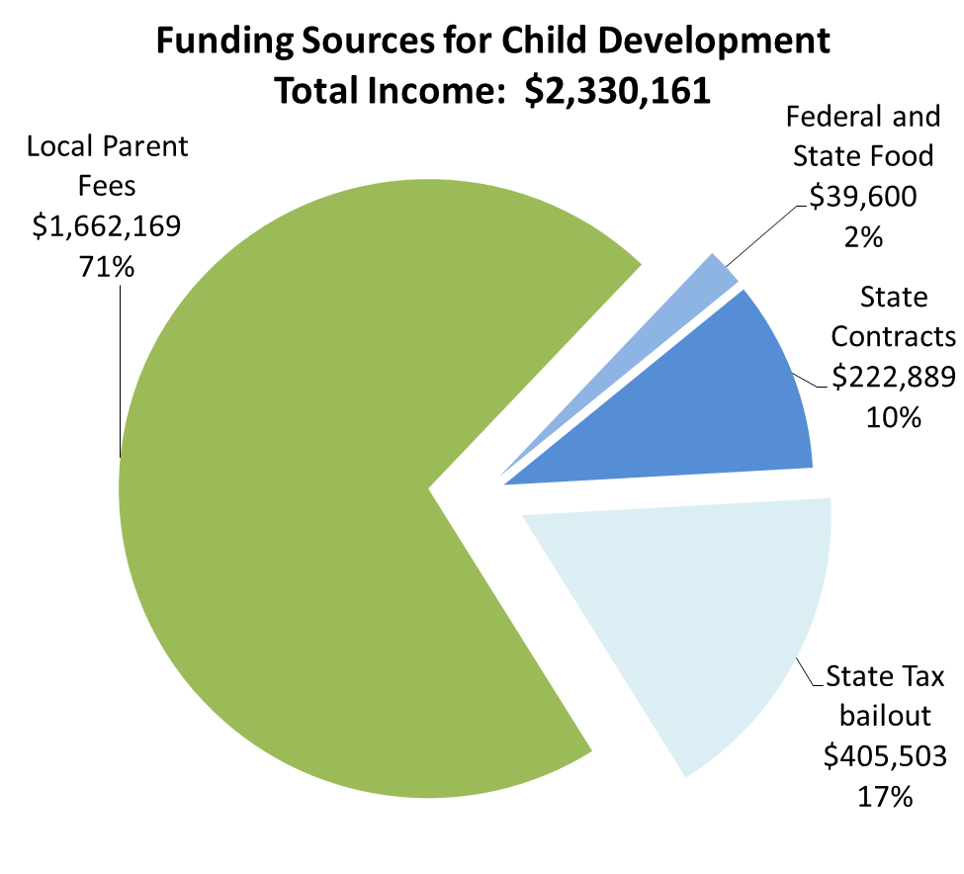

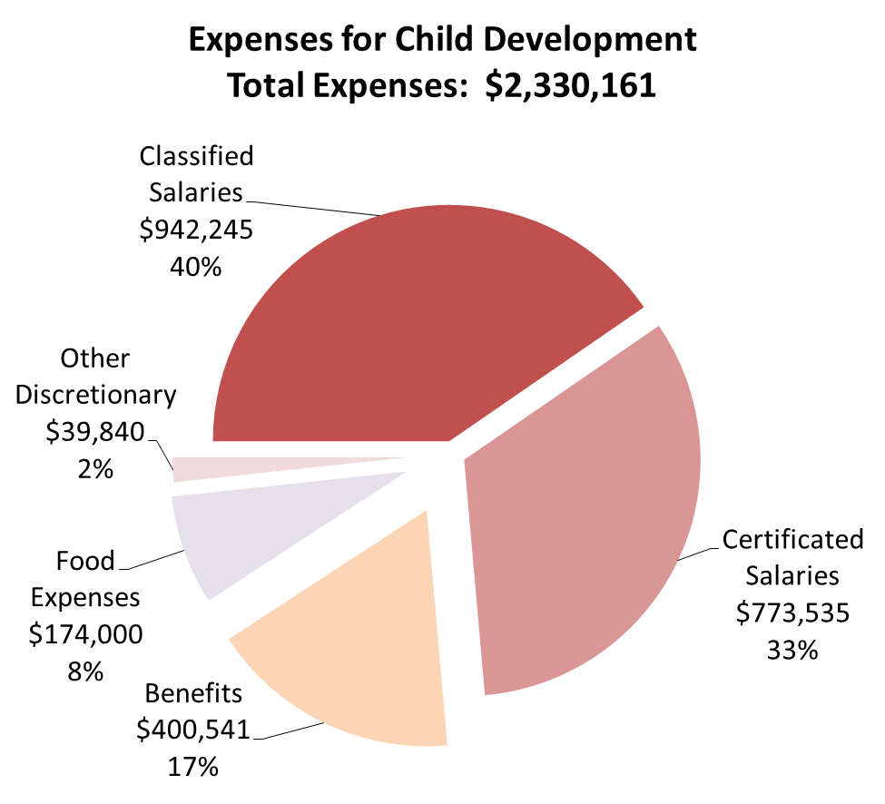
Strengths

- The program is financially self-supported with its 2013-2014 income.

- The program offers a quality laboratory school for Child Development Division, as well as a quality early childhood education for young children.

Weaknesses

- The program still depends on ‘tax bailout’ funds. The program continuously seeks other financial sources to become 100% self-supporting without tax bailout funds.

- There is currently a need to redesign a staffing plan that matches our current financial need/status, due to loss of support from the general fund and a 50% reduction of bailout funds.

Trends

Positive:
The program attracts and pertain highly qualified teachers, offers a quality program, and serves as a valuable laboratory for the students.

Negative:
40% of full-time teachers are contracted for 10 months only, even though the program is open 12 months to meet the needs of students and professional families in the community.

Quantitative Workload Analysis

Faculty: Based on the work hours as per contract. Number of college students assigned for Practicum courses. Number of students assigned for the assessments.

Classified Staff: Based on the work hours as per contract and monthly time sheet. Number of the students assigned for the assessments.

Qualitative Measurement

Evaluations are given by the parents, peers, and administrators, based on both formal and informal observation.

Planning Agenda

Provide a quality Early Childhood Care and Education program to student-parents to support their college success.

Sustain a solid business operation.

Establish a business plan to become 100% financially self-supporting without state bailouts.

Provide a tool to student interns to teach successfully in the field of Early Childhood Education.

Strategic Planning

1. How does your program respond to /address the College’s strategic initiatives?

- Support student-parents to succeed in college.

- Provide real-life work experience to students in diverse settings.

- Serve as a bridge with the community through the Early Childhood Education program.

- Which initiative does your program service respond to, and in what ways is the response measured and evaluated?

Initiatives: “Individual Attention to Student Retention and Success”
“Cultural Competency”

In 2014, a survey of student-parents was conducted to identify their satisfaction level with the Early Childhood Education and Care, and identify the number of student-parents whose child’s enrollment in the CDC made it easier for the parents to take classes and jobs.

The CDC plans to conduct surveys of child Development students to measure their level of learning gained through real-life work experience opportunities as well as the level of their understanding about diversity in work settings.

Survey

A survey was conducted of 20 student-parents to identify 1) how the enrollment of their child in the CDC has helped them, 2) the satisfaction level of several program characteristics. Survey questions and results are below:

- Has your child’ s enrollment in this program made it easier for you to accept a job/keep a job/ accept a better job/ attend an educational or training program?

2. How satisfied are you with the characteristics of this program?

- How does the work of your program or services respond to increased access, growth, and retention and/or student equity?

The CDC “does not discriminate on the basis of sex, sexual orientation, group identification, race, ancestry, national origin, religion, color, or mental or physical disability in determining which children and families are served|” (Parent Handbook, 2013-2014, Page 7). The program provides childcare access to all eligible students who require childcare to attain an AA degree, certificate and/or to transfer to a university.

- What other programs/services are you working with to accomplish your proposed goals/outcomes?

  - Child Development Instructional division
  - Counseling
  - Star Vista (provides educational consultation to low-income student families by a community grant)
  - WestEd (staff training)

- What is important to understand about your program, or services and the consequences to the college if it was discontinued or reduced?

- Student-parents will lose access to campus childcare while they attend classes.

- Students who major in Child Development will lose a valuable on-site lab school where they engage in Practicum courses.

- Students will lose paid internship opportunities (their salary is paid out of community sources).

