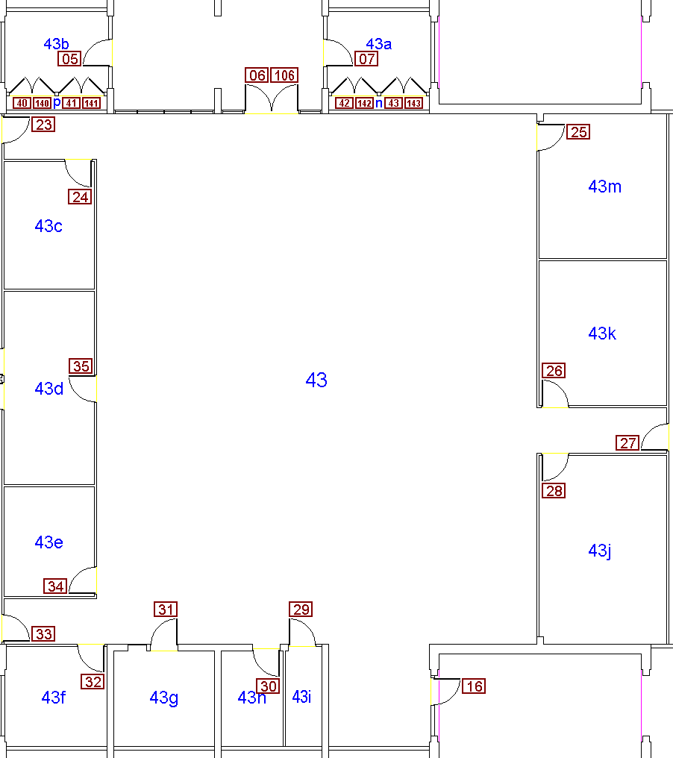

Student
Computers
Enter
&
Exit
Sign-In & Out Here

EnableMath
&
Student
Computers

Student
Computers

Student
Computers

Instructional
Support
Technicians

Group
Tutoring
Room

Reference
Textbooks

SSC
Co-Director

The Math, Science & Technology
Resource Center
Drop-In Algebra

MPS
Drop-In
Tutoring
Individual Tutoring
and Office Hours Tables

Group
Tutoring
Rooms
Drop-In
Calculus,
Physics, Chem & Bio
Drop-In
Stats & Finite
Student
Computers

Drop-In
PreCal, Trig & Calculus

MSTRC
Welcome, Info,
Resources & Materials Desk

S43

MPS
Counselor

